**PART A : MULTIPLE CHOICE SECTION 15 MARKS**

1. Besides excreting harmful and unwanted substances the kidneys also:

a) deaminate proteins.

b) transform glucose into the polymer glycogen.

c) regulate the fluid content of the blood.

d) manufacture urea.

2. Which of the following describes the pathway of a waste molecule which is excreted by the kidney?

a) Bowman’s capsule 🡪 glomerulus 🡪 tubule 🡪 ureter 🡪 bladder

b) glomerulus 🡪 Bowman’s capsule 🡪 tubule 🡪 urethra 🡪 bladder

c) Bowman’s capsule 🡪 glomerulus 🡪 tubule 🡪 urethra 🡪 bladder

d) glomerulus 🡪 Bowman’s capsule 🡪 tubule 🡪 ureter 🡪 bladder

3. Consider the concentration of water in blood of the artery supplying the kidney and in the blood of the vein leading from the kidney. Which of the following statements is correct?

a) The concentration of water in the blood of the artery supplying the kidney is greater than the concentration of water in the blood of the vein leading from the kidney.

b) The concentration of water in the blood of the artery supplying the kidney is less than the concentration of water in the blood of the vein leading from the kidney.

c) There is no significant difference between the concentration of water in blood of the artery supplying the kidney and in the blood of the vein leading from the kidney

d) It is difficult to measure the concentration of water in blood of the artery supplying the kidney and in the blood of the vein leading from the kidney.

4. Consider the diagram below.

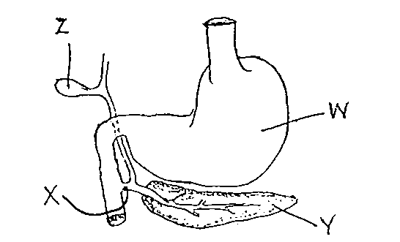

Which of the following pairs of substances pass through structure X?

a) hydrochloric acid and bile.

b) bile and pancreatic juice.

c) salivary amylase and intestinal juice.

d) gastric protease and hydrochloric acid.

5. The function of the villi and microvilli in the small intestine is to:

a) decrease the amount of exposed surface

b) increase the total area of enzyme retention

c) increase the total area for absorption

d) all of the above

6. Which one of the following nutrients, after digestion, could be expected to enter the blood stream via the lymphatic system?

a) starch

b) milk sugar

c) protein

d) fat

7. When passing from the stomach to the duodenum, food must pass through the

a) pyloric sphincter

b) oesophagus

c) bile duct.

d) cardiac sphincter

8. In the large intestine the following nutrients are absorbed.

a) amino acids and fats

b) water

c) carbohydrates and fibre

d) water, some minerals and vitamins

9. The intestinal enzyme that digests protein is:

a) maltase.

b) sucrase.

c) protease.

d) lipase.

10. The most effective and least harmful way of increasing peristalsis in order to prevent constipation is to:

a) eat more foods containing roughage.

b) drink smaller quantities of water.

c) take gentle laxatives.

d) refrain from exercising after meals.

11. The basic building blocks of lipids include:

(a) amino acids only.

(b) fatty acids and amino acids.

(c) fatty acids and glycerol.

(d) saccharides and glycerol.

12. Urine produced under normal conditions should contain:

(a) water, urea and uric acid.

(b) glucose, water and protein.

(c) water, sodium and protein.

(d) glucose, urea and water.

13. People with coeliac disease are unable to tolerate:

(a) A protein called gluten

(b) A carbohydrate called gluten

(c) A protein called glycogen

(d) A carbohydrate called glycogen

14. The organic nutrient with the highest energy content is:

(a) lipids

(b) proteins

(c) carbohydrates

(d) sugars

15. The location in the kidneys of Bowman’s capsule and Loop of Henle are:

(a) pelvis and medulla respectively

(b) medulla and cortex respectively

(c) cortex and medulla respectively

(d) Both are located in the medulla

**END OF PART A**

**PART B: SHORT ANSWER SECTION 25 MARKS**

**Complete each of the following questions in the spaces provided.**

16. There are four organs of the body which are involved in excretion of unwanted substances from the body. Describe each of these by completing the following table.

(8 marks)

|  |  |
| --- | --- |
| Excretory organ – 1 mark per organ | Substances excreted |
| Lungs (1) | Carbon dioxide (1) |
| Kidneys (1) | Urea, uric acid, water, salts, creatinine  (1/2 mark each – must give at least 2) |
| Skin (1) | Urea, lactic acid, water, salts  (1/2 mark each – must give at least 2) |
| Alimentary canal/ large intestine (1) | Bile pigments (1) |

**17.** Parts (a), (b) and (c) of the question refer to the diagram of the nephron shown below.

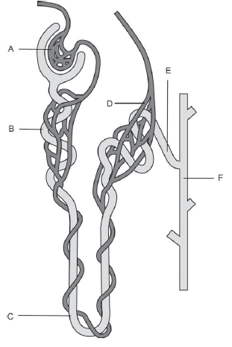

1. Identify the structures labelled ‘B’ and ‘C.’ (2 marks)

B: Proximal convoluted tubule

C: Loop of Henle

1. State the function of the structures labelled ‘A’ and ‘D’. (2 marks)

A: Glomerular filtration/ filters blood/ forces small substances in blood into Bowman’s capsule (1 mark)

D: Selective reabsorption or tubular secretion (1 mark for either)

(c) What functions does the structure labelled ‘E’ performs that affects the composition of

urine? (2 marks)

Water and salts are selectively reabsorbed from E (distal convoluted tubule). (1)

Other metabolic wastes may also be actively transported into E for excretion. (1)

(d) Name the organ of the body that produces urea. (1 mark)

Liver

18. Parts (a) and (b) of the question refer to the diagram of the digestive system below. 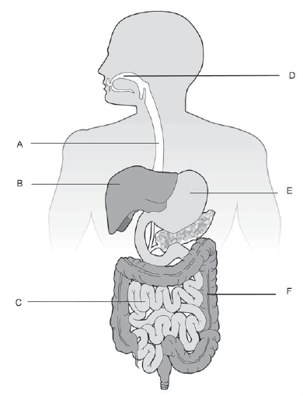

1. Identify the structures labelled ‘A’ and ‘B’. (2 marks)

A: Oesophagus

B: Liver

1. Various functions of the digestive system are listed below. Match these functions with the labelled structures in the diagram above.

Some of the functions described may match more than one labelled structure. Make sure you list **all** the structures that perform that function. Use the **letters** from the diagram above in your answer.

(4 marks)

Chemical digestion:­­­­­­­­­­­­­­­­­­ D, E, C

Chemical digestion of proteins: E and C

Absorption of nutrients and/or water: C and F

Bile production: B (**½ mark for each correct answer)**

19. Kidney failure can happen suddenly but is more likely to develop over a period of years. Name two causes and two treatments for kidney failure. (4 marks)

Causes: Drug use

Smoking

Diabetes

High blood pressure (any two causes for 2 marks)

Treatment: Kidney transplant (1)

Dialysis (1)

**END OF PART B**

**PART C: EXTENDED ANSWER SECTION 10 MARKS**

20. Identify the organs involved in the digestion of proteins and lipids.

Describe how each organ will assist in the digestion of these two organic substances.

(10 marks)

|  |  |  |
| --- | --- | --- |
| ***1 mark for mentioning 4 out of 5 organs below*** | **Lipids** | **Proteins** |
| **Mouth** | • Mechanical digestion by teeth, tongue and cheek muscles | |
| **Stomach** |  | • Chemical digestion of protiens  • By pepsin / gastric protease  • Polypeptides broken down into di-peptides |
| • Mechanical digestion of both lipids and proteins  • Churning mechanism of stomach (and addition of gastric juices) turns food into soup-like liquid called chyme | |
| **Pancreas** | • Pancreatic lipase secreted into the duodenum/small intestines  • Break down lipids into fatty acids and glycerol | • Pancreatic protease secreted into the duodenum/small intestines  • Break down di-peptides into amino acids |
| **Small Intestines** | • Intestinal lipase secreted by intestine walls  • Break down lipids into fatty acids and glycerol | • Intestinal protease secreted into the duodenum/small intestines  • Break down di-peptides into amino acids |
| **Liver** | • Produces bile  • Emulsifies lipids  • Enhances digestion by enzymes by increasing SA which they can act upon. |  |
|  | ***Max of 9 marks*** for any of the points above. Appropriate terminology must be included and used correctly to receive the mark. | |